COMPANION DOCUMENT
SAMPE would like to thank you for your participation as an author for the upcoming conference. Please know that, upon its acceptance, your paper will be published in the conference proceedings.
The format of your paper is very important. This detailed companion document will explain the use of the paper template provided for you to use formatting your paper. This document addresses how to create new headings and sub-headings, as well as referencing, figures and table formatting.
Note that there are five sections in the template: Introduction, Experimentation, Results, Conclusions, and References. You are not limited to using only these sections and may add or change sections as appropriate for your paper.
In addition to formatting guidelines, SI Units of measure are REQUIRED. You may add English units in addition to SI Units. Be sure to check your paper against the Paper Requirement Check List (page 2) before submitting your paper.
Key words: SAMPE now requires key words to be included on the first page of your technical paper. Please add 1-3 keywords.
Do not hesitate to contact Rocio Figueroa with any questions at rocio@sampe.org or +1.626.540.4112.

TECHNICAL PAPER REQUIREMENTS

CHECKLIST
The following Checklist is meant to provide the author(s) with a quick check against mandatory SAMPE Technical Paper Requirements in order to avoid paper rejection. You MUST conform to these requirements or your paper will be rejected from consideration.
◻ Paper is technical in nature and is not marketing oriented.

◻ Microsoft Word format only

◻ SI Units of Measurement are used as primary measurement
- Times New Roman font only to be used for Technical Paper, including graphics
- Do not include editing details. Do not show mark-up.
- Include keywords in your paper
- Technical Paper conforms to sample margins, paper size, and format (use template to ensure compliance)
- Other than the copyright statement (if applicable), nothing should be inserted into the margins of the paper, this includes foot notes and page numbers.
- Appropriate Copyright Statement on bottom of first page of Technical Paper for Copyright options B or C only (Copyright Option A doesn't require a note):
O Copyright B: Copyright 2021 by [Copyright holder's name]. Published by Society for the Advancement of Material and Process Engineering with permission.)
O Copyright C: This paper is declared a work of the U.S. Government and is not subject to copyright protection in the United States.
- Technical Paper page length (including both text and graphics) 15 pages maximum
- Each Open Technical Paper submitted electronically through the SAMPE 2021 website, https://sampe.fluidreview.com/
- Obtain proper clearance and permission required to release this paper. All responsibility regarding the contents and security clearance of papers submitted rests solely upon you, the author, and not upon SAMPE or any of its members.
- Pre-register for the conference by deadline provided by SAMPE. Authors receive a discounted registration rate.

TITLE
FirstName MI. LastName1, FirstName MI. LastName2, FirstName MI. LastName3
Company Name
Street Address
City ST Zipcode
ABSTRACT
Include a succinct 100-200 word abstract about your paper.
Keywords: Include 1-3 words

1. INTRODUCTION
Somewhere early in the introduction, you need to indicate the specific topic of the report. Some introductions seem to want to hold readers in suspense for a while before they indicate the true topic. That's a bit of a gamble. A better approach is to indicate the topic early—such that you could circle the topic words somewhere in the first three to four lines of the introduction.

1.1 Sub-heading
Somewhere, the report needs to indicate why it was written, for whom, and for what purpose. If the report provides recommendations on whether to implement a program, the introduction needs to indicate that somehow. You might also consider indicating something of the scope of the report—what it is not intended to accomplish.

1.2 Audience
The introduction also needs to indicate who are the appropriate or intended readers of the report—for example, "experienced technicians trained on the HAL/6000." Also, an introduction should indicate what level of experience or knowledge readers need to understand the report, if any. If none is needed, say that also. If the report was prepared for council members of the City of Utopia, Texas, the introduction needs to express that.

1.3 Overview of contents
The introduction to a report should, if nothing else, indicate the main contents of the report. Often this is done with an in-sentence list, as the examples in this part of the chapter illustrate (a bulleted vertical list is a bit overdoing it). For most reports, some sort of scope indication is also needed in the introduction: some statement about what topics the report does not cover.

1.4 Background on the Topic
This is everybody's favorite! Some minimal background is usually in order for an introduction— for example, some key definitions, some historical background, some theory, something on the importance of the subject. Information like this gets readers interested, motivated to read, grounded in some fundamental concepts. Watch out, though—this discussion can get away from you and fill up more than page. If it does, that's okay; all is not lost. That just shows the information is important and should be in the report—just not in the introduction. Move it in to the body of the report, or into an appendix.

1.5 Background on the Situation
Another kind of background is also a good candidate for introductions—the situation that brought about the need for the report. For example, if there were a lot of conflicting data about some new technology or some problem, which brought about the need for the research, this background could be summarized in the introduction. For example, if a company needed new equipment of some kind or if the company had some problem or need and some requirements in relation to that equipment—discussion of these matters should go in the introduction.

1.6 Heading
To create a heading, type the name of the heading on a line by itself:
Example Heading
From the menu, click on Format – Styles and Formatting. A frame will appear on the right-hand corner of your screen.

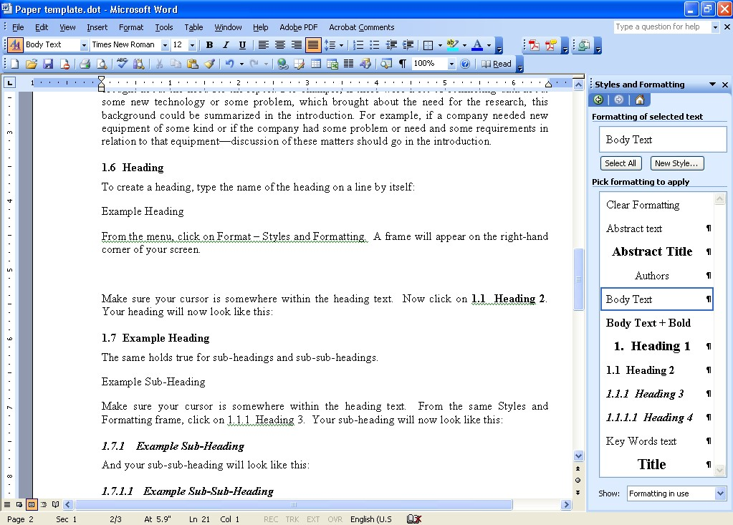
Figure 1. A screen capture showing the Styles and Formatting Frame.

Make sure your cursor is somewhere within the heading text. Now click on 1.1 Heading 2. Your heading will now look like this:

1.7 Example Heading
The same holds true for sub-headings and sub-sub-headings.
Example Sub-Heading
Make sure your cursor is somewhere within the heading text. From the same Styles and Formatting frame, click on 1.1.1 Heading 3. Your sub-heading will now look like this:

1.7.1 Example Sub-Heading And your sub-sub-heading will look like this:

1.7.1.1 Example Sub-Sub-Heading
Here is the text that follows the sub-sub-heading.

2. MAJOR HEADING

What if we want to add a new Major Heading to the report? For example, let’s add a section titled Experimentation.
First type the text for the new section on a line by itself. Experimentation
Now, using the Styles and Formatting frame, click on 1. Heading 1 (make sure your cursor is somewhere within the heading text). Your major heading will now look like this:

3. EXPERIMENTATION

You now can create major headings, sub-headings and sub-sub-headings for your technical paper.

4. RESULTS

Most technical papers have a results section.

5. FORMATTING

5.1 Formatting of Text
Earlier in this document we discussed the formatting of the Major Headers and sub-headers of the document.
This section and the next will discuss formatting of text in the body of the paper. The key to proper SAMPE formatting is the correct use of the Styles and Formatting function of MS Word. There are a couple general rules of thumb:

- Avoid using Enter (or carriage return) to create a space between paragraphs.
- Never use the space bar or tabs to position text within a line.

For example, I originally typed the text shown above like this:
Never use Enter (or carriage return) to create a space between paragraphs.
Never use the space bar or tabs to position text within a line.
Then I highlighted the text, and selected List Bullet from Styles and Formatting. This automatically formatted the text correctly.
All regular text in the body of the paper should have a Body Text style.

5.1.1 Space between numerical value and unit symbol
In the expression for the value of a quantity, the unit symbol is placed after the numerical value and a space is left between the numerical value and the unit symbol.
The only exceptions to this rule are for the unit symbols for degree, minute, and second for plane angle: °, ', and ", respectively, in which case no space is left between the numerical value and the unit symbol.
Example: α = 30°22'8"

Note: α is a quantity symbol for plane angle.
This rule means that:
- The symbol °C for the degree Celsius is preceded by a space when one expresses the values of Celsius temperatures.
Example: t = 30.2 °C but not: t = 30.2°C or t = 30.2° C

- Even when the value of a quantity is used as an adjective, a space is left between the numerical value and the unit symbol. (This rule recognizes that unit symbols are not like ordinary words or abbreviations but are mathematical entities, and that the value of a quantity
should be expressed in a way that is as independent of language as possible.) Examples: a 1 m end gauge but not: a 1-m end gauge

a 10 kΩ resistor but not: a 10-kΩ resistor
Note: to create the ‘º’ symbol, while holding down the ‘Alt’ key press 0186 on the numeric keypad. Alt-0186 = º

5.1.2 %, percentage by, fraction
When it is used, a space is left between the symbol % and the number by which it is multiplied.
Further, the symbol % should be used, not the name “percent.”
Example: x_{B} = 0.0025 = 0.25 % but not: x_{B} = 0.0025 = 0.25% or x_{B} = 0.25 percent

Note: x_{B} is the quantity symbol for amount-of-substance fraction of B

5.1.3 Typefaces for symbols
The three major categories of symbols found in scientific and technical publications should be typed or typeset in either italic or roman type, as follows:
—symbols for quantities and variables: italic; —symbols for units: roman;

—symbols for descriptive terms: roman.
Symbols for quantities are italic, as are symbols for functions in general, for example, f (x):
t = 3s t time, s second T = 22 K T temperature, K kelvin
r = 11 cm r radius, cm centimeter _{λ} = 633 nm _{λ} wavelength, nm nanometer

Symbols for vectors are boldface italic, symbols for tensors are sans-serif bold italic, and symbols for matrices are italic:

A·B = C (vectors) T (tensors) A =  a a1121 aa 1222 

The symbols for units and SI prefixes are roman:

m meter g gram L liter
cm centimeter μg microgram mL milliliter

6. EQUATIONS, FIGURES AND TABLES

6.1 Equations
Chemical equations are unique and numbered consecutively using Arabic numbers enclosed in brackets. The numbers are placed flush at the right hand margin.
Equations should be inserted using the Microsoft Equation Editor. Equations should not be typed using ASCII text.
This is an example of a bad equation. Spaces and/or tabs should NEVER be used to position the equation number on the right margin.
2C₆H₅CHO+H₂O→ C₆H₅CH₂OH+C₆H₅COOH [1]
The best way to handle equation formatting is to put the equation and the equation number into a table.
First, insert a table with one row and two columns.

Now format this table by selecting Table – Properties... Make sure the entire table is selected.
With the Table tab chosen, click on Center, then OK. This will center the table on the page.
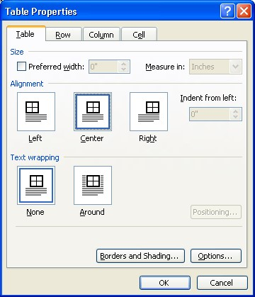

Next, select the Cell tab. Again, select Center, then OK. This will center the text you type within the row of the table.
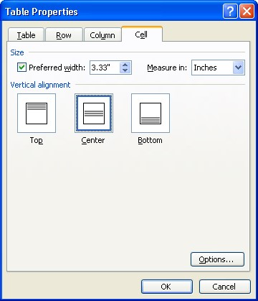

Now place your cursor in the left column of the table and insert your equation. Once completed, select Equation from Styles and Formatting. This will center the equation in the table.

c
=

a
²

+

b
²

Now place your cursor in the right column. Type in the equation number, enclosed in brackets.

c = a ² + b ² | [1]

To position the equation number to the far right, select Equation Number from Styles and Formatting.

c = a ² + b ² | [1]

To finish formatting the equation table, place your cursor over the dividing line between the two columns. Drag the vertical line as far to the right as it will go.

c = a ² + b ² | [1]

Now eliminate the border around the equation. Make sure your cursor is in the equation table. From the menu, select Table – Table Properties ... In the Table tab, select Borders and Shading. In the Borders tab, select None as the Setting. Now, although you can see the outline of the table, this line will not print.
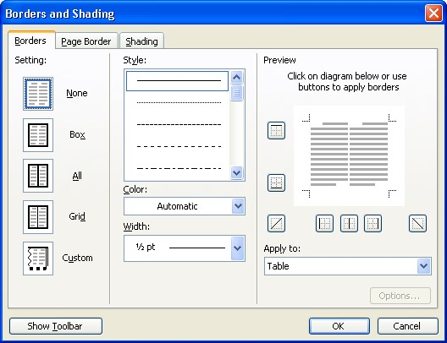

c = a ² + b ² | [1]

Finally, if you wish, you can hide the table outline as well. With your cursor somewhere in the table, sect Table from the menu, then click on Hide Gridlines.

c = a 2 + b 2 [1]

6.2 Figures
Number figures as they appear throughout the paper, beginning with Figure 1. There should be a line space between the bottom of the figure and the figure label. To format the figure label, select the Figure Label style. The figure label should be placed below the figure.
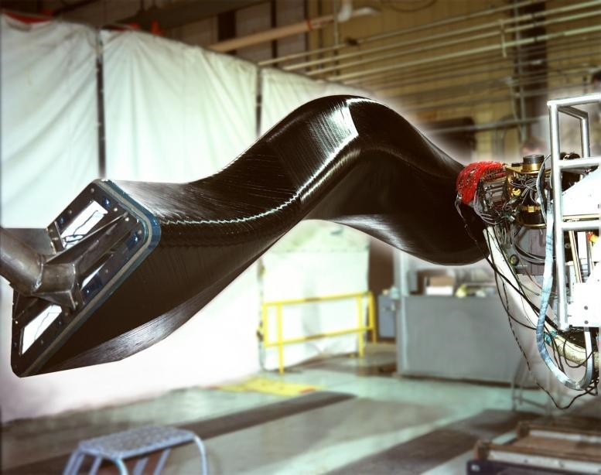

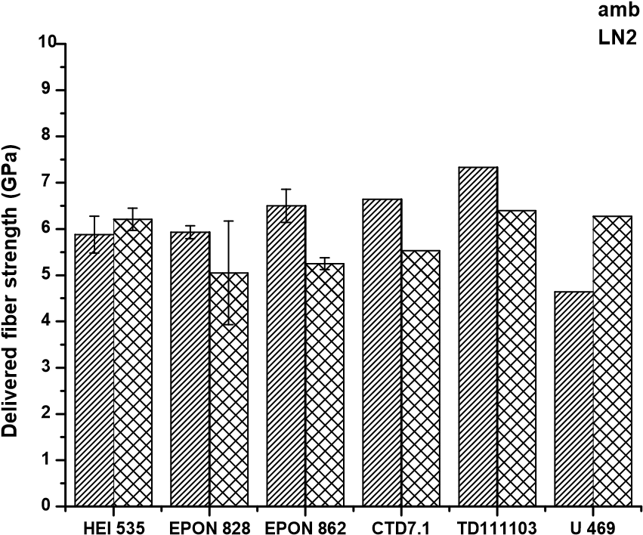
Figure 1. Fiber placement machine building a complex, high performance carbon fiber aircraft engine duct (FP machine on right side). (Photo courtesy of ATK)

Figure 2. Delivered fiber strength for various resin systems with T1000 fiber based on COPV burst tests.
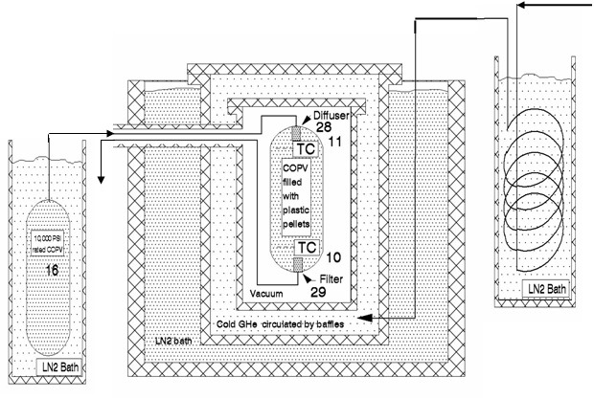
Figure 3. Schematic of the liquid helium (LHe) burst facility at NASA-MSFC.

6.3 Tables
Tables should be centered and numbered consecutively, first listing Table, followed by the number it appears in the paper. There should be a line space between the Table label and the Table. The table label should be placed above the table.
To format the figure label, place the cursor within the label, then select the Table Label style.

Table 1. Natural fiber types and general families.

 | Plant and Cellulose Fiber Types
Bast Fibers | Flax, Hemp, Kenaf, Jute, Mesta, Ramie, Urena, Roselle
Leaf Fibers | Pineapple, Banana, Sisal, Srew Pine, Abaca, Curaua, Agaves, Cabuja, Henequen, Date Palm, African Palm
Seed Fibers | Cotton, Kapok
Fruit Fibers | Coconut, Coir
Wood Fibers | Hardwoods, Softwoods – many numerous types (~10,000 varieties)
Grasses and Reeds | Wheat, Oat, Barley, Rice, Bamboo, Bagasse, Reed, Corn, Rape, Rye, Esparto, Elephant Grass, Cannary Grass
Table 2. A few typical mechanical and physical properties of natural fibers compared to their commercial and aerospace counterparts (Ref. 1, 2, 3, in part).

Fiber | Density (gm/cm²) | Tensile  Strength (ksi) | Tensile  Modulus  (msi) | Range of  Elongation (%)
Flax | 1.50 | 75 – 215 | 4 | 2.7 – 3.2
Hemp | 1.47 | 100 | 10 | 2.0 – 4.0
Kenaf | 1.45 | 135 | 7.7 | 1.6
Jute | 1.30 | 55 – 110 | 3.8 | 1.5 – 1.8
Ramie | 1.50 | 60 – 135 | 8.9 – 18.6 | 3.6 – 3.8
Sisal | 1.50 | 75 – 90 | 1.4 – 3.2 | 2.0 – 2.5
Coir | 1.20 | 85 | 0.6 – 0.9 | ~30
Cotton | 1.55 | 60 | 0.8 – 1.8 | 3 – 10
E-Glass | 2.56 | 290 – 350 | 10 | 3.0
S-Glass | 2.57 | 665 | 12.5 | 2.8
Aramid  (Commercial) | 1.44 | 435 – 455 | 9 – 10 | 3.3 – 3.7
Carbon (PAN Std. Mod.) | 1.67 | 580 | 33 – 35 | 1.4 – 1.8

Table 3. Common TP matrix processing temperature and maximum service temperature limits. This table is wider that the page margins – it is an example of a bad table. Also, units should be shown in the table header, not in the table cells. Table 2 has this correctly.

Thermoplastic Resin Matrix | Typical Processing  Temperature Range, ºC | Maximum Service Temperature Limits (*)
PEKK – Polyetherketoneketone | 327-362 | 149C / 300F
PEI – Polyetherimide | 329-357 | 210C / 410F
PPS – Polyphenylene Sulfide | 321-343 | 140C / 285F
PEEK – Polyetheretherketone | 385-413 | 171C / 340F
PI – Polyimide | 280-399 | 316C / 600F
PAI – Polyamideimide | 280-343 | 260C / 500F

7. ADDITIONAL REQUIREMENTS

There are a few additional sectional requirements.
Just as we began this paper with an INTRODUCTION, we will end the paper with a section titled CONCLUSIONS. This may also be titled SUMMARY, or SUMMARY AND CONCLUSIONS.
The final section of the paper will cite the REFERENCES you have used.

8. CONCLUSIONS

We normally use the word "conclusion" to refer to that last section or paragraph or a document. Actually, however, the word refers more to a specific type of final section. If we were going to be fussy about it, this section should be called "Final Sections."
There seem to be at least four ways to end a report: a summary, a true conclusion, an afterword, and nothing. Yes, it is possible to end a document with no conclusion (or "final section") whatsoever. However, in most cases, that's a bit like slamming the phone down without even saying good-bye. More often, the final section is some combination of the first three ways of ending the document.

8.1 Summaries
One common way to wrap up a report is to review and summarize the high points. If your report is rather long, complex, heavily detailed, and if you want your readers to come away with the right perspective, a summary is in order. For short reports, summaries can seem absurd--the reader thinks "You've just told me that!" Summaries need to read as if time has passed, things have settled down, and the writer is viewing the subject from higher ground.

8.2 "True" Conclusions
A "true" conclusion is a logical thing. For example, in the body of a report, you might present conflicting theories and explored the related data. Or you might have compared different models and brands of some product. In the conclusion, the "true" conclusion, you'd present your interpretation, your choice of the best model or brand--your final conclusions.

8.3 Afterwords
One last possibility for ending a report involves turning to some related topic but discussing it at a very general level. Imagine that you had written a background report on some exciting new technology. In the final section, you might broaden your focus and discuss how that technology might be used, or the problems it might bring about. But the key is to keep it general--don't force yourself into a whole new detailed section.

8.4 Combinations
In practice, these ways of ending reports combine. You can analyze final sections of reports and identify elements that summarize, elements that conclude, and elements that discuss something related but at a general level (afterwords).
Here are some possibilities for afterword-type final sections:

- Provide a brief, general look to the future; speculate on future developments.
- Explore solutions to problems that were discussed in the main body of the report.
- Discuss the operation of a mechanism or technology that was discussed in the main body of the report.
- Provide some cautions, guidelines, tips, or preview of advanced functions at the end of a set of instructions.
- Explore the economics, social implications, problems, legal aspects, advantages, disadvantages, benefits, or applications of the report subject (but only generally and briefly).

8.5 Revision Checklist for Conclusions
As you reread and revise your conclusions, watch out for problems such as the following:

- If you use an afterword-type last section, make sure you write it at a general enough level that it doesn't seem like yet another body section of the report.
- Avoid perfunctory conclusions that have no real reason to be in the report.
- Keep final sections brief and general.

9. REFERENCES
References should be cited throughout the paper, whenever applicable, using square brackets.
Your references may come from a variety of sources. Each should be formatted according to the examples shown in the following sub-sections. There are some general rules of thumb:

- Italicize titles of books, magazines, and scholarly journals. Enclose title of articles, essays, poems, and short stories in quotation marks.
- If no author is given, start with the title and then the date.

9.1 Names
The author name should be formatted as Last Name, followed by First Name. If the author’s name is Isaac Asimov, the name should be formatted:
Asimov, Isaac.,
If more than one author is listed, then:
Asimov, I., Brown, C. & Jackson, S. L.,

9.2 Article Title
The title of the article should be in quotes:

“Consequences of Dirac's Theory of the Electron”

9.3 Journal name
The journal name should be in italics:

Journal of Advanced Materials

9.3.1 Citing a Journal Article
Author last name, first name, middle initial (as applicable). "Article title." Title of periodical Date of periodical (or, if a consecutively paginated journal, volume number, followed by year in parentheses): Pages.
Dubeck, Lawrence. “Science Fiction Aids Science Teaching.” Physics Teacher 28 (1990): 316- 318.
If the article is in a journal that starts each issue with page one:

Wilcox, Roland. “Shifting Roles and Synthetic Women in Star Trek: The Next Generation.” Studies in Popular Culture 13(2) (1991): 53-65.

9.4 Book
Author last name, first name. Title. Place of publication: publisher, year published. Allison, Peter. Whatever You Do, Don't Run. Guilford, CT: Lyons, 2008. 9.4.1 Article in a Reference Book

Coulter, Ellis Merton. "John Adair." Dictionary of American Biography. Ed. Allen Johnson. Vol.
1. New York: Scribner's Sons, 1964.

9.5 Government Publication
"Deaths by Major Causes: 1960 to 2002." United States. Census Bureau. Statistical Abstract of the United States: 2004-2005. 124th ed. Washington, DC: GPO, 2004.

9.6 Proceedings
LastName, FirstName. “Conference Paper Title.” Conference Title. Conference location, date. Ed. Conference Editor(s). Publisher. Publication medium.

9.6.1 SAMPE Proceedings (hardcopy)
Powell, G.L., Janke, C.J., and Barber, T.E. “Nondestructive Inspection of Heat Damage to Graphite-Epoxy Laminates Using Diffuse Reflectance Fourier Transform Infrared Spectroscopy”. Proceedings of 29th International SAMPE Tech. Conf. Orlando, Florida, May 4- 8, 1997. Society for the Advancement of Material and Process Engineering. pp. 766-775.

9.6.2 SAMPE Proceedings (CD-ROM)
Perton, M., Blouin, A., Gu, Z., Monchalin, J.P., Gay, E., Berthe, L., Boustie, M. and Arrigoni, M. “Laser Shock Waves for Adhesive Bond Testing.” SAMPE Technical Conference Proceedings: New Materials and Processes for a New Economy. Seattle, WA, May 17-20, 2010. Society for the Advancement of Material and Process Engineering. CD-ROM—15 pp.

9.7 ASTM Standard
ASTM Standard D7091-05, 2005, "Standard Practice for Nondestructive Measurement of Dry Film Thickness of Nonmagnetic Coatings Applied to Ferrous Metals and Nonmagnetic, Nonconductive Coatings Applied to Non-Ferrous Metals" ASTM International, West Conshohocken, PA, 2005, DOI: 10.1520/D7091-05, www.astm.org.

9.8 Web Sites
Author. "Article Title." Publication information for a print source. Site Name. Site Editor.
Electronic publication date. Subscription information for databases. Pages only if numbered. Sponsoring Institution, City, ST or Country. Date site accessed <url>.

9.8.1 Basic Entry
Goodwin, Sue and Welling, Shielda, Reference Librarians. From the MLA Handbook for Writers. 6th ed. New York “Works Cited: MLA Style.” Lone Star College-Kingwood Library, Kingwood, TX. 14 Oct 2008. <http://kclibrary.lonestar.edu/mlastyle.htm>

9.8.2 No Author
The MLA Style Manual. 13 Oct. 2008. Wikipedia, the free encyclopedia. 14 Oct. 2008 <http://en.wikipedia.org/wiki/MLA_style>.

9.8.3 Author, No Date
Mazer, Cary M. Bernard Shaw: A Brief Biography. 16 Sept. 2007
<http://www.english.upenn.edu/~cmazer/mis1.html>.

